

COMP3851A – Computing and Information

Systems Work Integrated Learning Part A

Progress Report

Author:
Wangyang Lin, C3468608
Taru Nigam, C3509116
Haoyu Zhou, C3502992
Alicia Jennifer Ann Joseph, C3512047
Ertai He, C3512068
Chang Yan, C3502614

UON Peer Connect

Research Background
University life invariably presents stresses that transcend the classroom. In response, institutions typically muster an arsenal of support options—counselling, peer mentoring, extracurricular societies designed for connection. Sadly, significant numbers of students fail to benefit, often for overlapping reasons: shame, logistical obstacles, and plain ignorance of what’s available. Research by Eisenberg, Hunt, and Speer (2012) reveals that only 36 percent of students struggling with mental health symptoms go on to seek assistance, with stigma and unclear referral channels cited as leading causes. The fallout is measurable and grim: those who avoid help typically suffer intensified psychological strain, drift away from academic responsibilities, and, in the worst cases, exit the institution altogether. Thus, the persistent gulf between what is offered and what is actually used stands out as a major impediment to measurable student health.

Beiter et al. highlight five main areas of struggle for students: time management, academic workload, mental health, social integration, and study skills. The high school to university transition does not typically move to a loose framework that requires self-direction. This self-direction may reveal gaps in future planning, prioritization, and help-seeking. Such self-regulated challenges are consistently reported to result in social isolation and increased anxiety (Terry et al. 2020). These challenges do not impact students equally: international and first-generation students, as well as students from marginalized backgrounds may contend with additional cultural, linguistic, financial, reduced social capital, and considerable uncertainty regarding institutional navigation. For these students, the consequences of failing to access timely support could be profoundly unset.

In response to some challenges, higher learning institutions are adopting more modern artificial intelligence solutions to assist their students, especially those that offer mobile and out-of-hours support. Chatbots and conversational agents are offering solutions that are scalable and available twenty four hours continuously serving to manage inquiries, provide relevant educational content, and assist users in accessing the required services (Følstad & Brandtzaeg, 2017). If designed well, the systems can greatly help in reducing the social costs associated with seeking help by compressing seeking help normalization, offering total privacy, and automating enriching next courses of action. They also help in creating a unified point of access to the many complex support systems that would otherwise be seen to be disorganized.

The UON Peer Connect project is aligned with this shift. It aims to build an AI buddy that converses with students naturally, identifies emotional nuances, and appropriately directs them to relevant resources. The system applies Natural Language Processing (NLP) and emotion-recognition technologies to respond to students in context, be it encouraging self-help modules, prompting study skills resources, or connecting users to counseling or academic support. Evidence is mounting in support of such tools: Inkster et al. (2018) demonstrated that non-clinical chatbots can mitigate distress through timely affirmations and problem-solving. Woebot and Wysa have also reported symptom relief for anxiety and depression through short, CBT-informed conversations (Fitzpatrick et al., 2017; Inkster et al., 2018). While UON Peer Connect is not a clinical product, it nevertheless embraces the principles of early intervention and empowering users through intervention that is unobtrusive and easy to access.

To reach those objectives, choices pertaining to design issues are important. The provision of access and inclusion needs to comply with the deeper order principles of the design approach. In this context, it entails offering multilingual responses for the most common languages on campus, offering responses in plain language, and text-only, low-bandwidth interactions. This also means sensitive phrasing and the avoidance of culturally misaligned idioms for non-native speakers. Also, the triage of the system should be clear, conservative, and self-limiting: the chatbot must refer to human assistance, present work arounds, or enforce rapid handover to pre-established university protocols when language suggesting risk (self-harm, harassment, acute distress) is present. In order not to become obsolete, the bot must be seamlessly and continuously updated integrated with resource directories on campus such as counselling, disability services, academic advising, peer mentoring, financial aid, and housing. These should also include current service hours, booking links, eligibility criteria, and anticipated waiting periods. Lastly, students should have the option to select to remain anonymous, where appropriate, with simple and clear disclosure of what data is collected and the rationale.

Equity and social justice issues are bound to arise. AI implementations are capable of replicating social biases and inequalities, especially when insufficient attention is paid to their tuning for different demographics. Emotion-recognition technologies may have difficulty with culturally specific ways of revealing distress, including through dialects and code-switching (Binns, 2018). There are also social considerations such as emotional privacy and emotional safety, alongside the concern that students might view a chatbot as a substitute for professional care when it is not (Jahanbin & Parvaneh, 2023). UON Peer Connect responds to these issues with privacy–by–design and equity-centered frameworks. Data will be anonymized and stored in accordance with the Australian Privacy Act of 1988. Pre-counters will state and clarify the chatbot's bounded capabilities: it is not a human counsellor, will never make diagnostic claims, and will always be bounded in its functionalities. Severe high-risk alerts will prompt the provision of human guidance, and any out-of-policy escalation will be qualified for review by trusted personnel. Also, the project will carry out routine fairness assessments, bias audits on the training and evaluation datasets, and measure model drift to ensure stable AI performance over time (e.g. fairness by evaluating intent detection accuracy and escalation rates across different language groups).

From the perspectives of research and development, UON Peer Connect serves as both an early-warning and a continuous-improvement system. On a de-identified, aggregated level, logs of conversations can be evaluated using text mining and sentiment analysis to uncover emerging issues, such as increased financial distress, assignment bottlenecks in particular courses, or housing insecurity around key census dates. Evidence-informed, targeted communication campaigns, staffing or service hour adjustments, or the development of micro-resources designed to mitigate recurrent pain points can be implemented as informed interventions (Papamitsiou & Economides, 2014). The governed analytics also have the capability to evaluate resource signposting and study the bridge between recommendation and outcome to ascertain what resources learners actually engage with post-signposting.

To achieve an effective value measurement, an evaluation plan is essential. The UON Peer Connect will monitor: (1) user engagement (overall unique users, session duration, return rate), (2) access as user engagement (successful service handovers, resource engagement through click, booking through click), (3) wellbeing and academic proxies (optional pre-interaction and post-interaction brief check-ins using ultra short validated scales like PHQ-4 or stress measuring single items), and (4) trust and effectiveness (System Usability Scale, trust about claimed usefulness, and clarity of given disclaimers). Capturing breadth and depth will require a combination of analytics, student interviews, and diary studies using a mixed-methods approach. Where appropriate, some A/B comparative tests can be done on different proposes to help seeking behavior (e.g. reduced stigma help seeking messages). Above all, all such measures must be based on consent and respect for privacy.

No less significant is the human aspect interacting with the technology. Student co-design should indicate tone, features, and escalation flows so that the bot is built from student perspectives rather than administrative fantasies. Staff instruction will prepare service teams to responsibly use the analytics data without slipping into automated triage processes. Change management and comms should center on destigmatizing help-seeking, Marketing Peer Connect as a companion that facilitates engagement rather than as a gatekeeper replacing human interactions. Governance is equally urgent: oversight needs to be specifically assigned, and a cross-functional group – counselling, student wellbeing, IT, equity & diversity, and the international office – should regularly review performance, fairness metrics, and escalation outcomes.

Savvy users of AI platforms will explain the limits of these systems. Every lived experience contains nuances that no chatbot can capture. Furthermore, there is always the risk of false negatives in risk detection systems. Without consent or clear boundaries, over-personalization can cross the line into unwanted intrusiveness. Language models, as noted, can hallucinate or suggest, with unwarranted confidence, steps that are beyond their given domains. Over-reliance on rigid regulations or closed and vetted, university-administered systems is risky. A dynamically evolving service environment calls for sustained accuracy of the information ecosystem, and continuous content governance, as opposed to single content build, to ensure accuracy
In terms of contribution to research, UON Peer Connect integrates learning analytics, digital mental health, and human-computer interaction. It puts into practice a particular theory of change where low-friction, stigma-sensitive dialogues enhance the likelihood of timely help-seeking; better access diminishes distress and sustains academic engagement; and aggregated and anonymized insights guide the institution as adaptive intelligence regarding the anonymized student population's needs. This supports the evidence that AI-facilitated, brief, structured conversations assist self-management and engagement, but only when designed ethically and positioned transparently (Fitzpatrick et al., 2017; Inkster et al., 2018; Abd-alrazaq et al., 2020).
In summary, the Peer Connect initiative aims to expand the AI-education-mental health intersection by solving a persistent problem—student help-seeking behavior. Through privacy, equity, and human partnership, Peer Connect seeks to motivate action, translating intention into actual help-seeking—turning awareness into use. It will enhance individual outcomes and the university’s holistic responsiveness—a system that listens, adapts ethically and continuously, and centers students.

Aims
The project objective is to create “UON Peer Connect,” an AI-supported conversational assistant specialized in addressing the academic, emotional, and social difficulties encountered by university students. The system will interact with students using Natural Language Processing (NLP) and emotion detection technologies to process their concerns and engage in empathetic dialogue, route them to the relevant services (counselling, academic support, or peer mentoring) at the university.
The main focus is to enhance the help-seeking behavior and student wellbeing by offering stigma-free services and restricted accessibility at any time. The AI is capable of conversing supportively and, as a result, will dismantle the obstacles to accessing support services and provide precise assistance in a timely manner.
The system will be designed with a focus on ethics, observance of privacy, fairness, and inclusivity, aligned with the Australian Privacy Act and UON policies, ensuring responsible and compliant use. The system will also feature an anonymized backend for analytics designed to monitor and capture gaps and emerging concerns for proactive institutional responsiveness.

Methods and activities
1. Understanding Students' Needs and Challenges
Method: Use a mixed-methods data collection methodology that combines quantitative and qualitative research.
Activities:
Conduct semi-structured interviews and questionnaires with a diverse set of students, academic advisors, and support staff to gain a thorough understanding of student difficulties (including stress and social concerns), identify unmet needs, and map the current support ecosystem. Analyze current university data (such as past survey results and inquiry logs) to uncover repeating themes and high-frequency problems.
Subject collected data to thematic categorization to create an extensive list of student issues, which will directly enrich the AI's knowledge base.
2. Designing and developing the Conversational AI Engine.
Method: Build a strong and scalable technical basis by employing powerful AI models.
Activities: Choose LLama 3 as the best conversational AI platform because to its advanced NLU capabilities and scalability.
Performing infrastructure provisioning by creating a dedicated local server environment. This guarantees secure, managed, and optimal hosting for the AI models, comprehensive knowledge base, and user interface.
Conduct NLU model training, with a focus on fine-tuning LLama 3 through data annotation for intent recognition and entity extraction.
Create discussion flows that facilitate sympathetic and successful conversations.
Use response generating logic with safety guardrails to ensure proper and helpful responses. Create a comprehensive knowledge base from university resources to give correct information, including mechanisms for quick retrieval of essential material.
3. Improving user experience and engagement.
Method: Focusing on user-centered design principles and encouraging continual improvement through direct user feedback.
Activities include developing a responsive, intuitive, and visually appealing web-based chat interface. Quick answer buttons and multi-language support (e.g., English and Chinese) are included to improve usability and accessibility for a varied student population.
4. Project management and quality assurance
Project supervision and quality control
Method: Using an agile development approach in conjunction with thorough quality assurance procedures.
Activities: Effective project management and team development through the use of agile sprints and reliable version control technologies.
In order to guarantee alignment with project objectives and expectations, a Communication Management Plan should be established with the project sponsor. This plan should include frequent progress reports, formal review meetings, and clear routes for input and decision-making.

Results
- During this semester, following the predefined methods, we first developed a series of structured questionnaires and conducted extensive interviews with students at PSB Academy. These interviews were carried out in both online and face‑to‑face formats to ensure diversity in participation. In total, we collected over 100 responses from undergraduate and postgraduate students across different disciplines. These responses captured both the academic and non‑academic challenges faced by students, alongside their expectations of how an AI assistant could support them. Preliminary analysis of the survey results revealed five recurring themes: academic stress(Course Difficulty), language difficulty, mental health concerns such as anxiety and isolation, financial challenges, and campus facilities problems. This dataset enabled us to identify the most pressing issues among students, thereby allowing us to design the AI system with greater alignment to their actual needs.
Figure 1 presents an example of the web‑based questionnaire used, and Figure 2 summarizes the distribution of reported challenges. These findings were instrumental in guiding the subsequent development and fine‑tuning of the AI model.

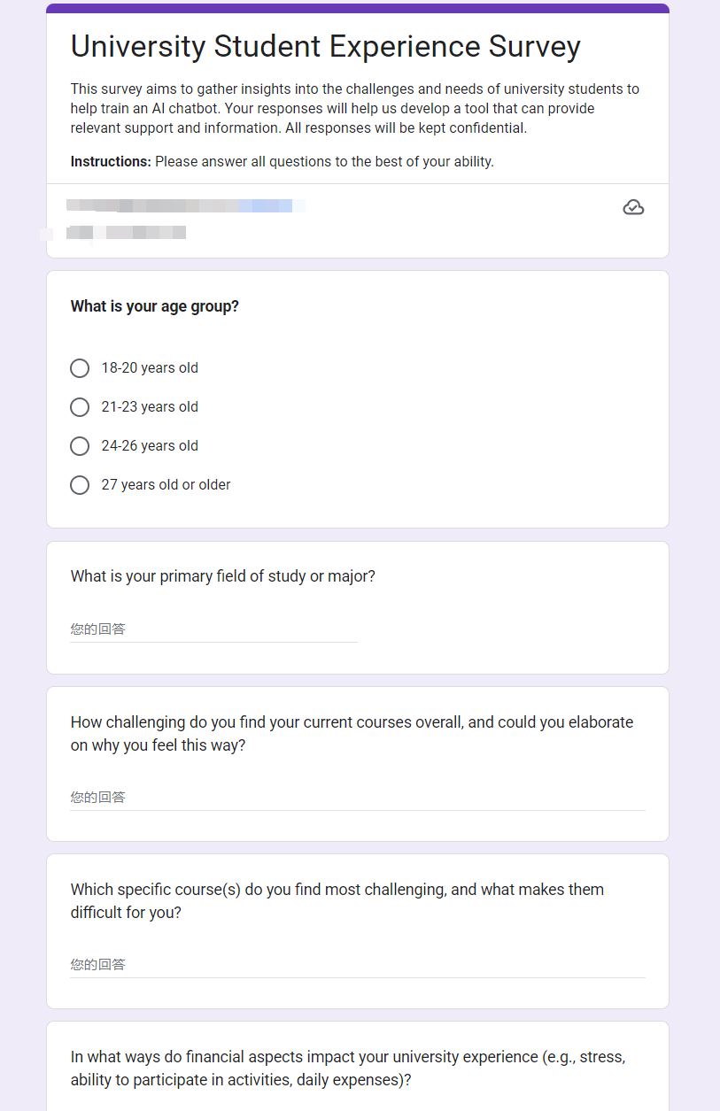
Figure 1
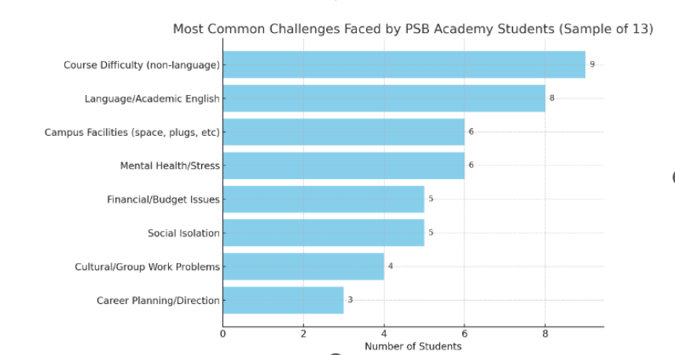
Figure 2

- In developing the UON Peer Connect AI assistant, we examined various open‑source AI models and ultimately selected LLaMA 3 (8B) as the foundation for the system. This choice was based on its relatively lightweight architecture, strong performance for entry‑level deployment, hardware efficiency, and the maturity of its development ecosystem, which allowed for straightforward local hosting. After establishing a dedicated on‑premises server environment and performing initial NLP fine‑tuning, we curated and annotated a dataset of over 500 counseling‑related Q&A pairs. Each entry was meticulously labeled with attributes such as issue category, psychological context, recommended solution direction, and severity level. This annotation process involved cross‑referencing publicly available psychological support datasets with university‑specific counseling materials, ensuring contextual relevance and cultural appropriateness for our student population. This dataset was then used to train and finetune the AI model to improve intent recognition, empathy in responses, and the relevance of problem solving suggestions.
One of the core challenges encountered was ensuring that the assistant’s tone remained empathetic without overstepping into the domain of professional counseling. To address this, we implemented a multi‑tier response strategy: for low‑risk emotional disclosures, the assistant provides reassurance and actionable self‑help suggestions (like CBT techniques); for moderate‑risk cases, it signposts institutional resources such as peer mentoring and academic support; and for high‑risk emotional indicators (like expressions of self‑harm or severe distress), it automatically provides immediate access to professional resources such as university counseling services and Singaporean crisis hotlines. These escalation protocols were reviewed by academic supervisors to ensure ethical compliance.
To further enhance system safety and reliability, we implemented response‑guard mechanisms to prevent inappropriate, irrelevant, or potentially harmful outputs. Additionally, the assistant was equipped with real‑time emotion analysis, enabling it to classify emotional intensity using a three‑level tagging system (low, moderate, high) and log anonymized insights in the backend database. These records are accessible only to authorized administrators (e.g. college staff), who may intervene with direct support when necessary. Figure 3 and 4 demonstrates two anonymized use‑case examples, with emotion analysis fields intentionally hidden from student users and visible only in the backend for testing purposes.
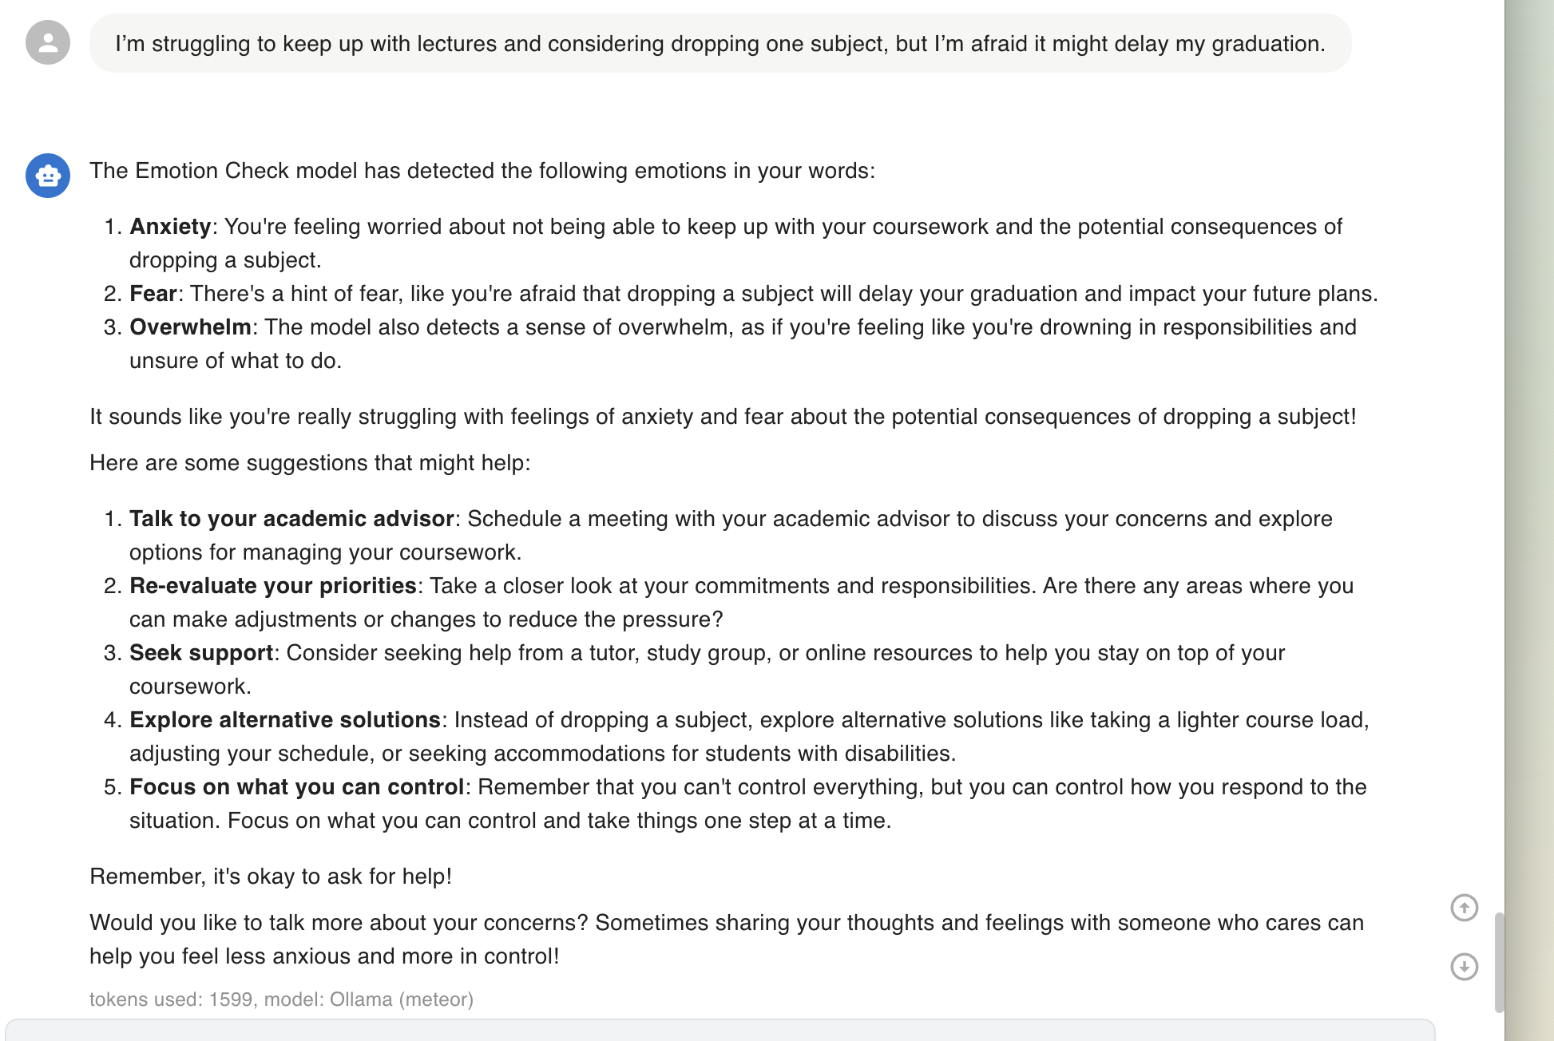
Figure 3
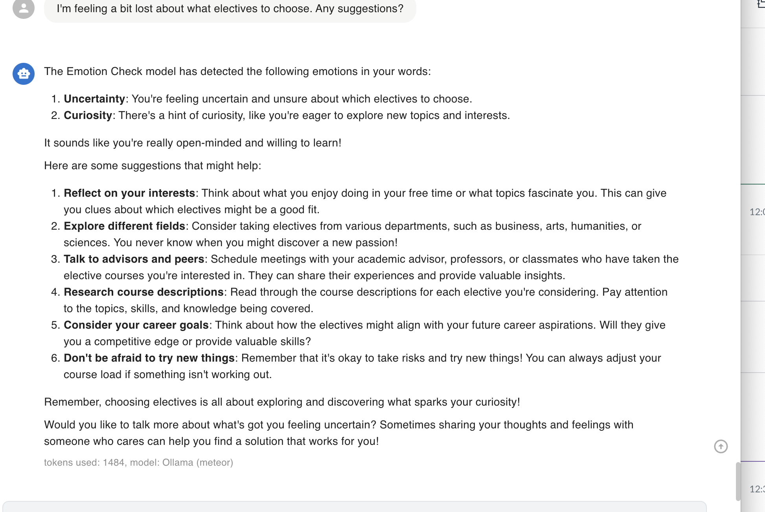
Figure 4

- On the user‑experience side, we created a high‑fidelity prototype of a responsive web‑based chat interface. The design incorporates quick‑reply options and plans for multilingual support (initially English and Chinese) to increase accessibility for diverse student populations. Informal usability testing with a small group of students indicated that the quick‑reply options reduced conversational friction, while multilingual support was highlighted as a critical feature for international students. These insights will be used to guide interface refinement in the next development phase.
Figure 5 shows the high‑fidelity prototype.
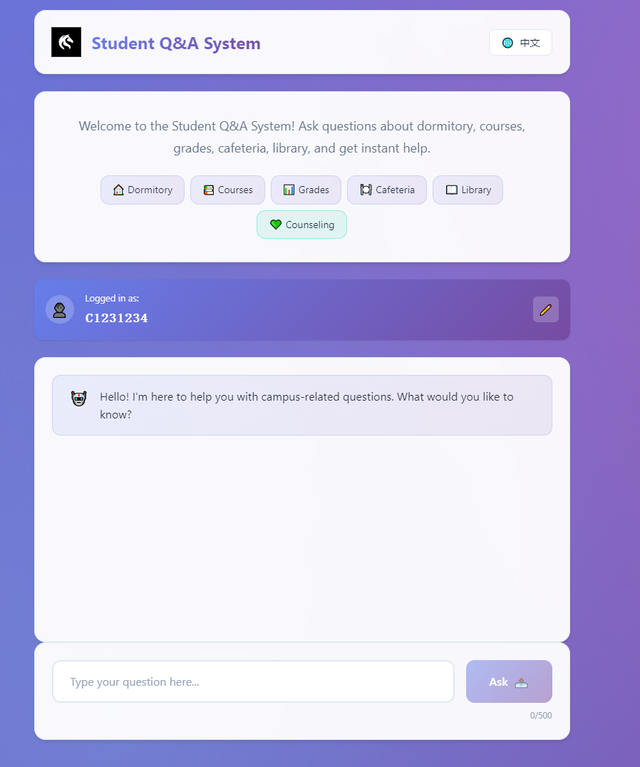
Figure 5

Despite these achievements, several limitations were identified in the current prototype. First, the dataset size remains limited (500 entries), which constrains the model’s coverage and accuracy in emotional and severity analysis. Second, due to the use of a lightweight model, the conversational memory is restricted to approximately 6 dialogue turns, limiting the system’s ability to handle complex, multi‑step discussions. Third, while the assistant successfully delivers empathetic and concise responses, its current interventions are basic, offering only simple suggestions, institutional contact information, and introductory CBT‑based techniques. In addition, the emotion analysis, though functional, requires further testing to improve reliability, particularly for culturally nuanced emotional expressions.
These findings will inform targeted improvements in the next development cycle. Specifically, we aim to expand the dataset to over 2,000 annotated entries, extend conversational memory using external context‑storage mechanisms, and integrate more advanced problem‑solving frameworks, including deeper psychoeducational content and guided self‑help modules. We also plan to conduct broader pilot testing with volunteer students and our friends to refine the system’s dialogue flow, validate the emotion analysis engine, and assess its real‑world effectiveness.
In summary, the initial results of the UON Peer Connect project demonstrate progress toward developing a culturally aware, ethically designed, and student‑focused AI assistant. While limitations remain, this semester’s outcomes provide a solid foundation for continued refinement and expansion in the following development phase.

Ethics
Ethics involved in the development of AI Buddy system are identified by our team; a few have been defined alongside a disambiguation strategy to be integrated into WIL Part B. However, we will now ask students neither real name nor gender to protect their privacy, but only allow authentication by student ID or cell phone number to ensure those accessing the system are the only authenticated university members. Students will be made aware beforehand about policies regarding data collection and usage before any interaction.
To prevent the chance of possibly biased or inappropriate responses, this coming term, we would have some further tests for the system-in-testing. This will include recruiting student volunteers and gathering feedback to refine the behavior of the model. For content safety issues, particularly where emotions are concerned, we have created a tagging mechanism to categorize emotional intensity. High-risk cases, such as self-harm or violent intent, will cause the AI to be programmed to recommend obtaining help from qualified professionals instead of giving independent advice.
In line with the data ethics policy of the university, such ethical interventions cater for a safe, inclusive, and trustworthy environment for the users. Further improvements may include enhancing transparency in AI responses and holding periodic reviews of stored interactions for compliance with ongoing ethical standards by academic staff.

References
Abd-alrazaq, A. A., Rababeh, A., Alajlani, M., Bewick, B. M., & Househ, M. (2020). Effectiveness and safety of using chatbots to improve mental health: Systematic review and meta-analysis. Journal of Medical Internet Research, 22(7), e16021. https://doi.org/10.2196/16021
Beiter, R., Nash, R., McCrady, M., Rhoades, D., Linscomb, M., Clarahan, M., & Sammut, S. (2015). The prevalence and correlates of depression, anxiety, and stress in a sample of college students. Journal of Affective Disorders, 173, 90–96. https://doi.org/10.1016/j.jad.2014.10.054
Binns, R. (2018). Fairness in machine learning: Lessons from political philosophy. In Proceedings of the 2018 Conference on Fairness, Accountability and Transparency (pp. 149–159). https://doi.org/10.1145/3287560.3287598
Eisenberg, D., Hunt, J., & Speer, N. (2012). Help seeking for mental health on college campuses: Review of evidence and next steps for research and practice. Harvard Review of Psychiatry, 20(4), 222–232. https://doi.org/10.3109/10673229.2012.712839
Fitzpatrick, K. K., Darcy, A., & Vierhile, M. (2017). Delivering cognitive behavior therapy to young adults with symptoms of depression and anxiety using a fully automated conversational agent (Woebot): A randomized controlled trial. JMIR Mental Health, 4(2), e19. https://doi.org/10.2196/mental.7785
Følstad, A., & Brandtzaeg, P. B. (2017). Chatbots and the new world of HCI. Interactions, 24(4), 38–42. https://doi.org/10.1145/3085558
Inkster, B., Sarda, S., & Subramanian, V. (2018). An empathy-driven, conversational artificial intelligence agent (Wysa) for digital mental well-being: Real-world data evaluation. JMIR mHealth and uHealth, 6(11), e12106. https://doi.org/10.2196/12106
Jahanbin, A., & Parvaneh, F. (2023). The ethical implications of ChatGPT AI chatbot: A review. Journal of Multidisciplinary Cases on Educational Research, 7(3), 1–13. https://jmcer.org/wp-content/uploads/2023/08/The-Ethical-Implications-of-ChatGPT-AI-Chatbot-A-Review-1.pdf
Papamitsiou, Z., & Economides, A. A. (2014). Learning analytics and educational data mining in practice: A systematic literature review of empirical evidence. Educational Technology & Society, 17(4), 49–64. http://www.jstor.org/stable/jeductechsoci.17.4.49

